**Azure Storage Account**

What is Azure storage account:

. **An Azure Storage Account** is a secure and scalable cloud storage container in **Microsoft Azure** that supports storing data in various formats like **blobs, files, queues, tables, and disks**. It offers high durability, redundancy, encryption, and access control, making it suitable for a wide range of modern applications and enterprise workloads.

Types of Azure Storage Account;

| **Type** | **Key Features** | **Best For** |
| --- | --- | --- |
| General Purpose v2 | Supports all storage services (Blob, File, Queue, Table, Disk) | Most common workloads and applications |
| Blob Storage | Optimized for object data with tiering (Hot, Cool, Archive) | Media, logs, backups, archives |
| BlockBlobStorage | SSD-backed high-performance block blob storage | AI/ML datasets, real-time workloads |
| File Storage | Premium file shares over SMB/NFS protocols | File server replacement, enterprise migrations |
| Premium Page Blob | Specialized for page blobs (used by Azure VM disks) | OS/data disks with high IOPS and low latency |
|  |  |  |

Data Redundancy Types in Storage account:

* **Zone-redundant storage (ZRS)** copies your data synchronously across three Azure availability zones in the primary region. For applications requiring high availability, Microsoft recommends using ZRS in the primary region, and also replicating to a secondary region.

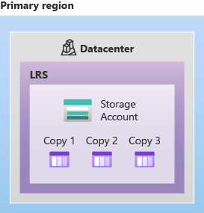

**Geo-redundant storage (GRS)** copies your data synchronously three times within one or more Azure availability zones in the primary region using LRS. It then copies your data asynchronously to a single physical location in the secondary region. Within the secondary region, your data is copied synchronously three times using LRS.

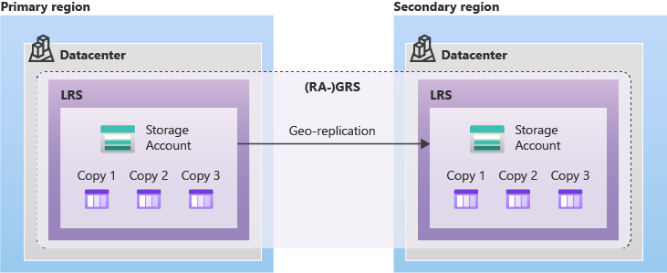

**Geo-zone-redundant storage (GZRS)** copies your data synchronously across three Azure availability zones in the primary region using ZRS. It then copies your data asynchronously to a single physical location in the secondary region. Within the secondary region, your data is copied synchronously three times using LRS.

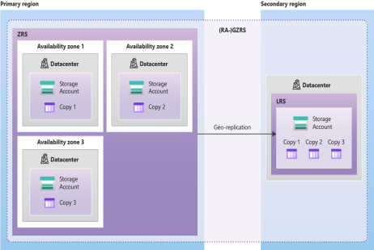

**How to Create AZURE STORAGE ACCOUN**T

Steps1: Go to azure portal search for storage account-> open storage account page->Then Click on create button.

